**Assessment, Inventory, and Monitoring Core Methods Training- Las Cruces, NM**

**Day 1:**

Wooton Hall, Jornada Experimental Range. Knox St. and Frenger St.

New Mexico State University, Las Cruces, NM

We will be in the large conference room downstairs for Day 1 (12 pm – 5 pm)

Park in the large parking lot on Knox St. You do not need a parking pass if you have a federal vehicle. We will be inside most of the day but will be outdoors for a soil texturing exercise, so come prepared!

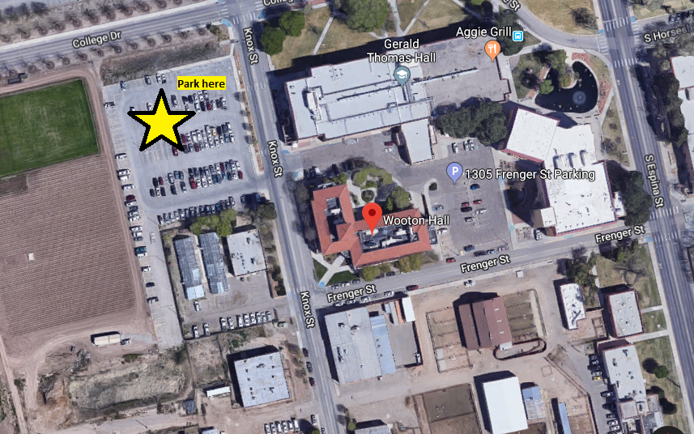

**Day 2:**

Meet at the Las Cruces BLM Office in the morning.

1800 Marquess St., Las Cruces, NM

Parking shouldn’t be an issue.

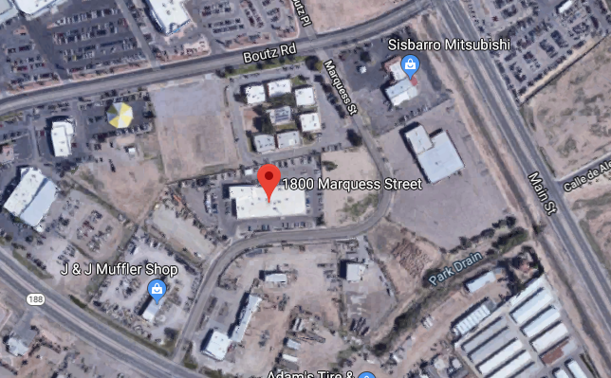

We will caravan to field site 1. Please carpool!

Field site 1: 32.3937 N, 106.9883 W  
Off of County Road C007 (Corralitos Rd)

**There is very limited shade at these sites! Temps are predicted to be in the high 90s, so come prepared with a big hat, long sleeves, and lots of sunscreen, water, and salty snacks.**

You can access this site by taking the airport exit 132 on I-10 west (there is a large Love’s gas station at this exit just west of Las Cruces) and following the frontage road for 4 miles west to Corralitos Road (C009, which will turn into C007 after the ranch headquarters). The road is graded the whole way and does not required 4x4.

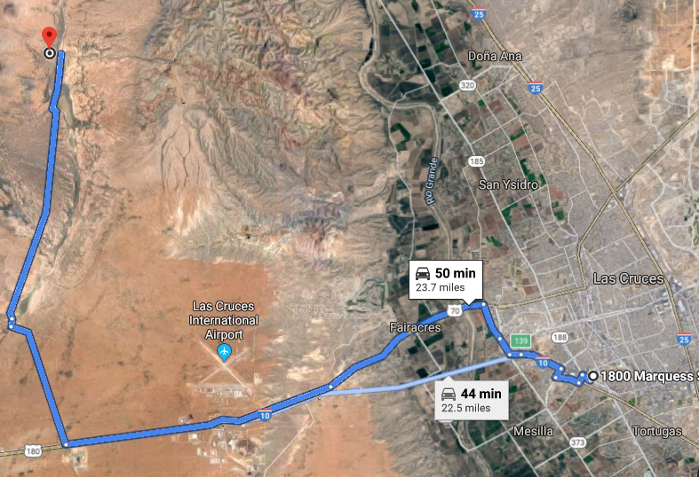

To get to site 2, we will backtrack down Corralitos Rd to practice plot characterization at a different ecological site.

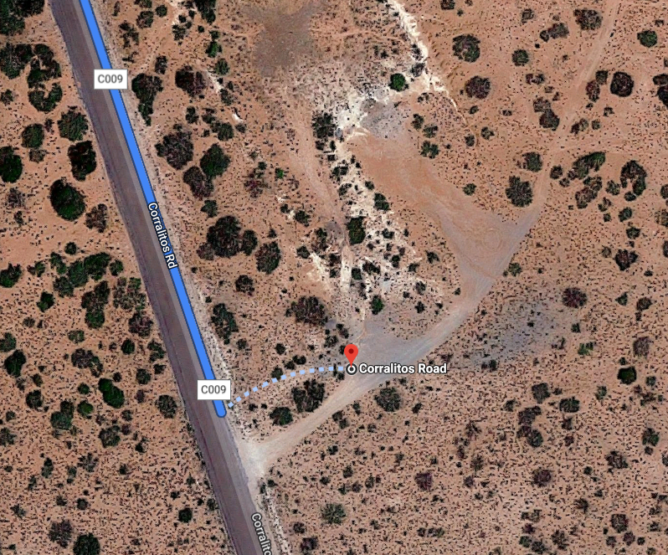

**Day 3:**

Meet at BLM office in the morning.

Caravan to field site

32.3120 N, 106.6488 W

From the BLM office, take Main St. south to University Ave. Follow University Ave east. It will eventually turn into Dripping Springs Rd. In about 8 miles, you will park at the entrance sign to Organ Mountains Desert Peaks National Monument. There is limited shade at the actual field site, but during lunch break, feel free to continue up Dripping Springs Road to La Cueva Picnic Area where there is shade, picnic tables, and bathrooms.

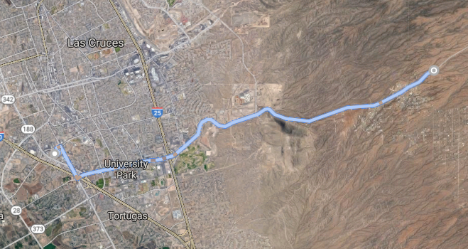

**Day 4:**

BLM Office