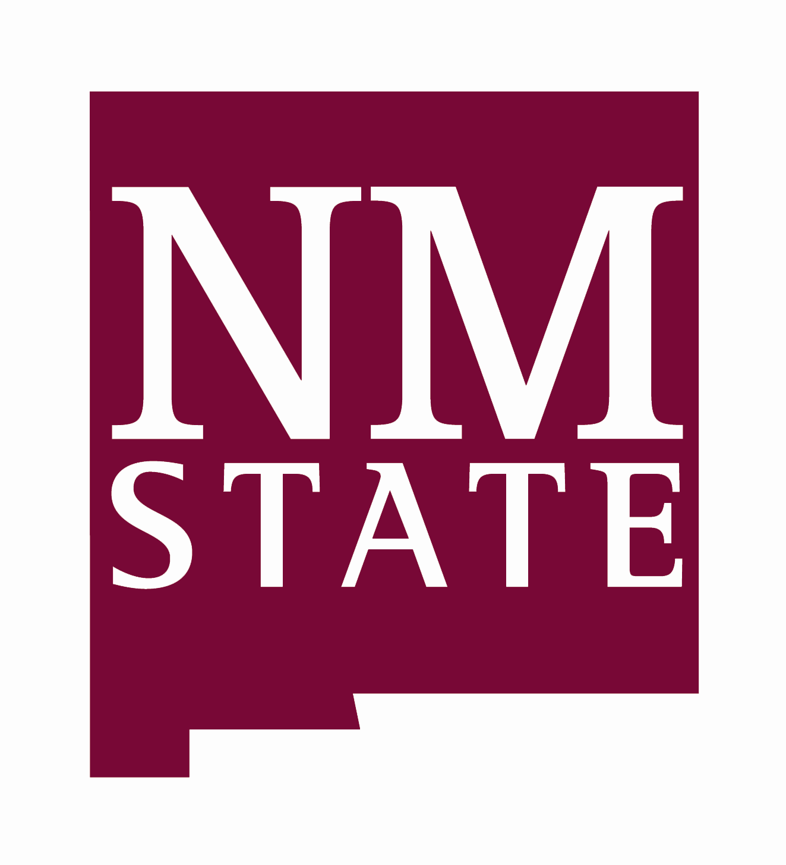
Dept. of Biology, Herbarium
****************
LIBRARY RATE
100247
****************
Herbarium (museum)
Specimens

DMM Sect. 483.2.3
Biology Annex 105
New Mexico State University
Las Cruces, New Mexico 88003-0001

TO:
Kathleen Nelson
Forest Botanist
Inyo National Forest
351 Pacu Lane
Bishop, CA 93514

